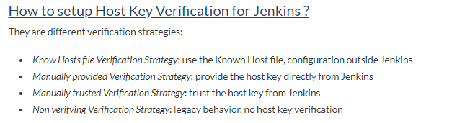**Known Hosts file Verification Strategy:**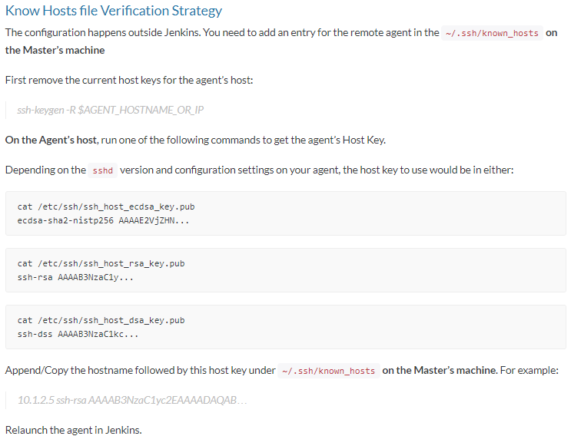

**Manually Provided Verification Strategy:**

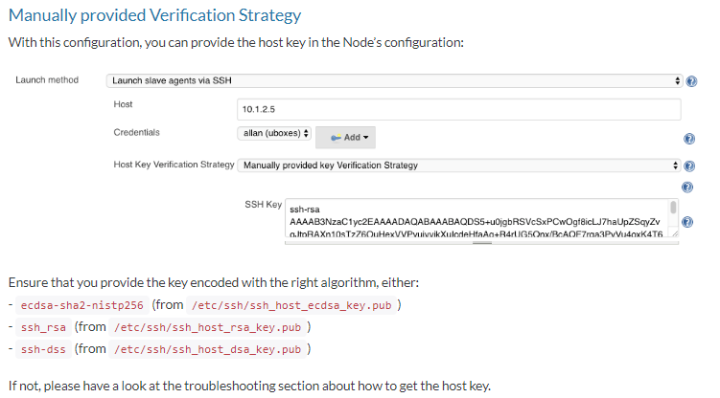

**Manually Trusted Verification Strategy:**

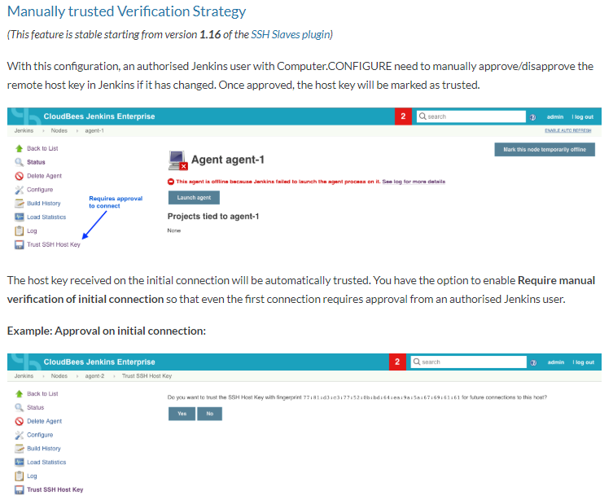

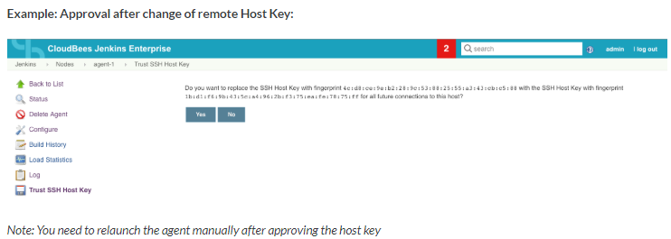

**Non-Verifying Verification Strategy:**

